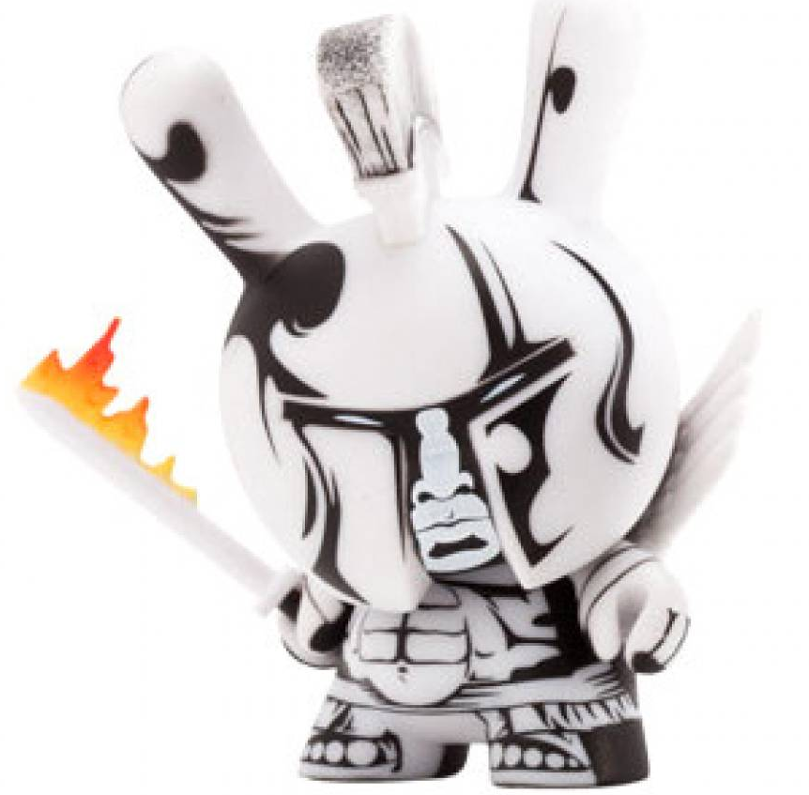
APHuG

MR. PARSONS
TPARSONS@CCISD.NET
THEMISTERPARSONS.COM
713-518-2794

TRAVEL HANDBOOK
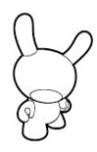
Clear Falls APHuG
Travel Handbook

AIRPORT/ PLANE
What you need to know about arrival: Passport Control and Customs…
- Do not separate as you go through passport control or custom. Wait just beyond each of the checkpoints you are approaching.
- You will proceed in this order when arriving at your first “port of entry” or when returning to the U.S.: Passport Control first, then Baggage Claim, then Customs (P-B & C sandwich).
- You and your group members should not have anything to “declare” on your way into foreign lands, so opt for the line that says “Nothing to Declare.” Once you’re through there, start looking for the EF representative carrying a sign or wearing EF apparel.
- On the way home, U.S. citizens must “declare” if you are bringing home more than $700 worth of goods. Each traveler will need to fill out a customs form; flight attendants will distribute these on the plane. (Before you leave the European Union or any other foreign land, ask your Tour Director about V.A.T. -- “value-added tax” -- refunds and where to process them at the airport. Travelers should think ahead and make sure those items are accessible, are not gift-wrapped, and have the corresponding receipts with them.)

What you need to know about being on the plane
- TRY AND GET 4-5 HOURS OF SLEEP
- Avoid caffeine and eat lightly.
- Get up and walk once every waking hour.
- Forget the flicks. Get some sleep whenever you can, but especially after dinner is served.
- Keep personal items and a change of clothes within reach - just in case.
- DO NOT wear contact lenses during plane trip; the pressurized cabin will caused them to adhere to wearers‘ corneas.
- Take Bonine or apply a medicated patch before boarding the aircraft if prone to motion sickness. (or wristbands)

BUS
- Never be late when traveling by coach.
- Keep your driver happy. Greet him daily. Help keep the coach clean. Be cordial.
- Play by his rules. “No ice cream” means NO ice cream on board.
- Make a passport check part of your routine every time you board the coach for the day. ("Put your hand on your passport!")
- Amenities: Bathroom? Maybe. Beverages? Maybe. Air-conditioning? Usually.
- Avoid "sensory deprivation" (iPods, Flappy Bird, etc.) under most circumstances. Try to soak up every sight and sound while on foreign soil. Especially when Tour Guides/Chaperones are speaking.
- Equip yourselves with maps. Keep track of where you are. It’s cool to follow along. GEO!!!
- Boys will be chivalrous Knights! Boys will get the suitcases out of the bus but ladies will be responsible for getting them into the hotel, airport, etc.
- When on board the coach you should refrain from talking anytime our city guide or tour director is using the microphone. It is super rude when people continue private conversations while being addressed by an expert historian who is proud of his or her city or country, and is anxious to share a treasure-trove of information.

HOTELS
- We will employ the “Clinkohan Maneuver” to expedite check-in:
  - All bags going to a particular floor go into the lift along with one person.
  - The bag-owners use the stairs, and meet the elevator to unload – fire-brigade style.
- In European hotels, keys are usually left at the reception desk whenever you leave the premises. The exception may be if you are given plastic card-swipe “keys” for electronic locks.
- Electricity
  - Adapters and converters: Modern electronics typically have built in voltage converters. Your cameras and personal electronics will require only the outlet adapter.
  - Personal grooming appliances can cause problems. I encourage “wash ‘n’ wear” hairstyles. Many hotels now provide in-room blow dryers.
- Noise/curfew
  - Hallways, stairwells, airshafts, courtyards and lobbies tend to echo and amplify sounds.
  - Exhausted kids sleep through guided tours and beautiful countryside. We will encourage “lights out” by a particular hour.
- Check-out
  - One person from each room will speak with the Chaperone at breakfast and confirm that everyone is awake in that room and preparing for departure.
  - Make a final "sweep" of each room for miscellaneous items, and be certain to claim items from hotel safe. All residents of each room should have a pre-check-out sweep.

RESTAURANTS
- I suggest that you pretend your favorite grandmother is serving you school-cafeteria-quality food. You should be polite and respectful toward the servers, and not make any overt negative comments about unfamiliar food. Facial expressions, attitudes, etc. are universal.
- Don't change meal status (vegetarian vs. omnivore) on the spur of the moment. This causes big, ugly problems with the restaurant staff.
- Don’t ever mess with people preparing what you will be consuming…trust me!
- Please, please, please...do not being "fussy" eaters while on tour.
- Try new things! Have an adventure! Have a story! Lunch is the great opportunity to experiment.

COMMUNICATION ISSUES
- There is NO ESCAPE. Tensions will mount and tempers will flare at some point during the trip. Guaranteed. It’s not unexpected.
- Sometimes roommates need a break from one another for a night or two.
- Please be respectful of others' things and needs.
- Preferably do not wear a lot of cologne or perfume. It can be brutal within the confines of a bus, and people who are allergic can become nauseous. Please do not fire it up on the bus.
- Be on time. Always. It is particularly upsetting to other groups if a member of your party has caused a delay for everyone on board.
- Be patient--with people and situations. With a large group of travelers, minor problems and delays are virtually unavoidable. Learn to smile...and deal with it.
- Your tour will be an exciting and intensely emotional experience for all involved. You may discover that you’ve established what may prove life-long friendships with others you hardly or never knew prior to the tour.
- Boyfriends or girlfriends back home? A missed phone call or a delayed response to a text message quickly results in assumptions of infidelity, and the distraught lover’s roommates become innocent victims wounded by the emotional shrapnel. Absence makes the heart grow fonder and all that crap. Enjoy your time on the trip. Send messages near Wi-Fi, don’t stress, they probably won’t be dead when you get back.
- Oh, please don’t fall in love on the trip. It’s just Rome, It’s not love.
SAFETY AND TRAVELING
- Groups of 3 or more to go somewhere.
- Always check in with your Chaperone when going somewhere – We should be able to quickly know where you went and locate you if needed.
- We will do occasional quick counts with your “pairs” and “squares”. Know where your roommates are and be able to quickly find them and account for each other. With a large group we can quickly get split up.
- THEFT … be aware of your surroundings. Some people’s jobs are specifically based on stealing from oblivious tourists. Don’t let them stay in business off of you!
- Don’t flash money.
- Move your backpacks to the front on busy trains or in busy areas, so you can keep better watch.
- When waiting at a depot or airport, we will have a couple folks watch bags so others can use restrooms or go for a walk. Always place the bags in a square pile with “squared” corners. That makes it easy to spot missing luggage immediately.
- Lavatory facilities vary from full showers (a rarity) to bare minimum: toilet, and sink with non-potable/drinkable, cold water.
- In the subways:
  - Once in the car, do not stand near the doors. You are an easy target for a “snatch-and-grab” thief. Pickpockets are skillful and opportunistic. Backpacks in front!
  - Know the name of the stop where you are to exit. Follow your progress on the map posted in the car.
  - When you exit the car, move to the wall on the platform until the Tour Director is certain all our group members are there.

AMBASSADORSHIP
- Beware: Many Europeans, South and Central Americans, and Asians understand English -- though they may not have overtly indicated that. They are as adept as anyone when it comes to reading non-verbal cues and messages. Don't put your foot in your mouth by making some sarcastic remark about their cuisine, their clothing, their accents, their seemingly leisurely pace of service, body odor, etc.
- We’ve given members of the global community reason to think many Americans are arrogant, loud, ill-mannered, self-centered gum-chewers. ESPECIALLY THE BRITISH. Be conscious of how you act, of the space you occupy, of the volume you generate. Don’t reinforce the stereotype of The Ugly American.
- Make an attempt, however modest, to speak their language, and remember that a simple smile goes a long way. At the very least, make it a point to greet local shopkeepers in their language as soon as you walk in their door.
- When on board the coach make it clear that passengers should refrain from talking anytime your city guide or your tour director is using the microphone. I can’t tell you how rude it seems when people continue private conversations while being addressed by an expert historian who is proud of his or her city or country, and is anxious to share a treasure-trove of information.
- I'll keep this simple: If my non-adult group members consume alcohol while on tour, they will be sent home.

EF TOUR’S RULES OF THE ROAD

All travelers must adhere to the following regulations while on tour:

All scheduled activities are obligatory. If you are sick or have a physical ailment that might prevent you from participating in an activity, you must tell the Group Leader, who should notify the Tour Director.

If you want to visit friends or relatives in a destination country, your Group Leader must be told before the tour begins. Please complete the Tour Release Form, found under Forms and Resources in your personalized website, to receive permission for the visits. You must then give the form to your Tour Director upon arrival.

You are expected to respect the nightly curfew that your Group Leader may set for your own safety and security. Room checks will be conducted at the Group Leader’s discretion. Visitors or group members of the opposite sex are not permitted in your room.

Smoking is not allowed on buses, during meals, in hotel rooms or in any other shared, enclosed space.

Hitchhiking and the driving or renting of any motor vehicle is strictly forbidden for all travelers.

You are required to pay for any phone calls or incidental personal expenses incurred at hotels. These will be payable the evening before departure at each hotel.

The consumption of hard liquor is strictly forbidden. Your parent may sign a consent form at the Group Leader’s discretion, giving you permission to consume the occasional glass of wine or beer with meals under the supervision of your Group Leader in countries where you are of legal drinking age.

Shoplifting, possession of illegal drugs and all other illegal activities will not be tolerated and are punishable by immediate dismissal from the tour. If you are involved in any illegal activities, all costs to return home are at your expense. If the local authorities are involved, you will be subject to the laws of the country you are visiting.

Payment for damage done to hotel rooms or to buses is your responsibility. If you notice any damage upon arrival at a hotel, you should notify the Tour Director immediately.
I, the undersigned, do agree to follow the above expectations and accept that there will be consequences to not adhering to them, including being required to return home early at my expense.

______________________________ ____________________________ ________________
(traveler name – PRINTED) (traveler name – SIGNED) (date)

______________________________ ____________________________ ________________
(parent name – PRINTED) (parent name – SIGNED) (date)

